**LEBANESE AMERICAN UNIVERSITY**

**USAID – HIGHER EDUCATION SCHOLARSHIP PROGRAM**

**HES - Volunteering Program Verification Form**

This form is to be used to document volunteering hours. If a student volunteers for multiple organizations, a separate form must be used for each organization. **This form must be turned in by the 28th of each month, the latest.**

I certify that the scholar Jinane Mohammad El Dawud completed a total of 5 hours of service at Life Sculptor.

The hours were completed hours as per the below:

Hours # 0 (date) _02/09 - 06/09_ (initials of supervisor) __A.K.___

Hours # 2 (date) _09/09 – 13/09_ (initials of supervisor) __A.K.___

Hours # 1 date) _16/09 – 20/09 (initials of supervisor) __A.K.___

Hours # 2 date) _23/09 – 27/09 (initials of supervisor) __A.K.___

Brief description of the activities the scholar performed or participated in:

As a member at the mental health research team, I’ve conducted a research about the effects of family dysfunction on mental health: how can it lead to mental health problems, the main mental health issues it causes and some factors that qualify a dysfunctional family; and another research about the link between loneliness and chronic diseases. In addition, I’ve done four outlines to present 4 workshop topics: digital marketing 2024: strategies for success, building a sustainable business: pathways to CSR excellence, AI and machine learning: shaping the future of industry, and remote work revolution: navigating the future of work.

Written feedback about the scholar’s performance:

Jinane conducted mental health research and developed 4 comprehensive workshop outlines on key topics. Impressive dedication to research and education.

Please rate the overall performance of the scholar at your organization:

|  |  |  |  |
| --- | --- | --- | --- |
|  | Mastery (5) | Proficient (3) | Emerging (1) |
| **Problem solver** | X |  |  |
| **Engaged & Committed** | X |  |  |
| **Open-minded & multicultural** | X |  |  |

Signature

& stamp

__________________________

_

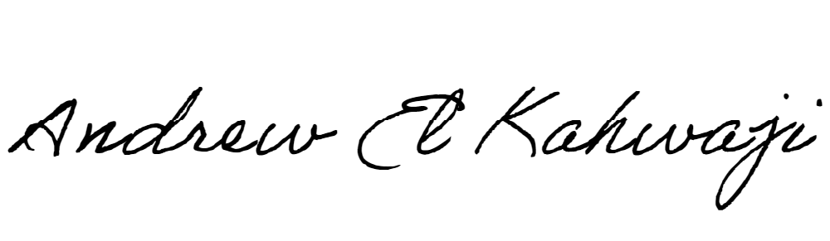

Printed Name _Andrew El Kahwaji_

Date __25/09/2024___

Email __andrew.lifesculptor.coo@gmail.com __

Phone __+961 71 914 378__

**LEBANESE AMERICAN UNIVERSITY**

**USAID – HIGHER EDUCATION SCHOLARSHIP PROGRAM**

